
INFORMATION SHEET FOR 24 HOUR BLOOD PRESSURE MONITORING.

- This monitor records your blood pressure over a 24 hour period.
- The blood pressure cuff which is placed on your upper arm and is attached to a small monitor which is placed around your waist.

- The cuff on your arm will inflate every 30 minutes on the hour and on the half hour during the day and hourly on the hour after 10 pm at night. This will happen automatically.

- Keep your arm straight and as still as possible while the cuff is taking a reading.

- It is recommended that you carry out your normal activities while wearing the monitor.

- Medications should be taken as prescribed unless otherwise advised.

- Do not have a bath or a shower for the 24 hours you are wearing this device.

- We will have another patient booked in for the monitor so it is important to bring the monitor back on time or get someone else to drop it back to the surgery.

- You can take it off yourself, un velcro and slip off cuff, take monitor off waist, and remove it from the carry case. Switch it off by flicking the black switch at the bottom to the 0. Put everything into a bag and drop off to reception, the report will be printed and left for the doctor to review; you will be contacted if any changes need to be made. If unsure come in and the nurse/doctor will remove it for you.

Time to remove monitor: _____________

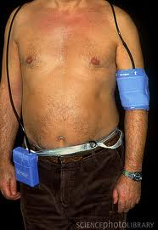
Time to bring back monitor: _______________

